Services Pages (do the same for the other services)

Behavioral Health
Hero:
Get your behavioral health providers seeing patients faster
Gusty Group manages the full licensing, credentialing and payer-enrollment lifecycle for behavioral-health groups; so a new hire goes from start date to first billable session quickly.
Services

(add licensing)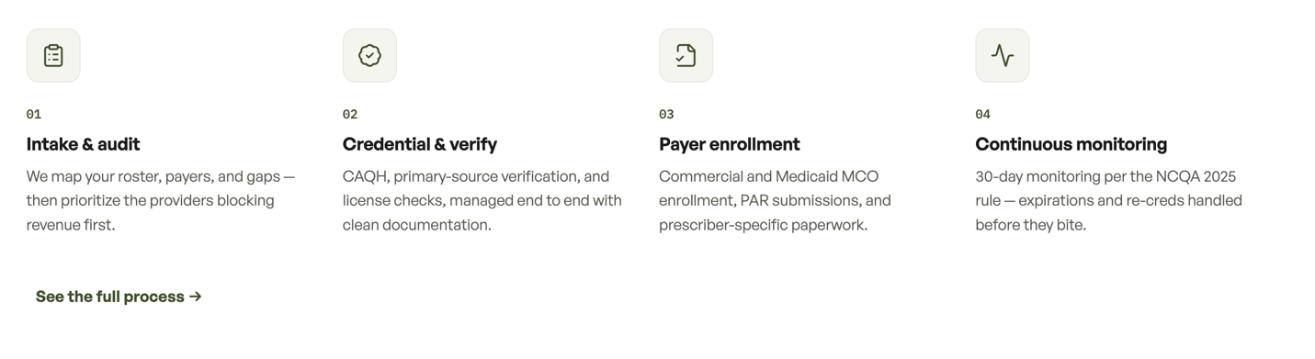
[Book a discovery call]

Expertise across behavioral and mental health specialties
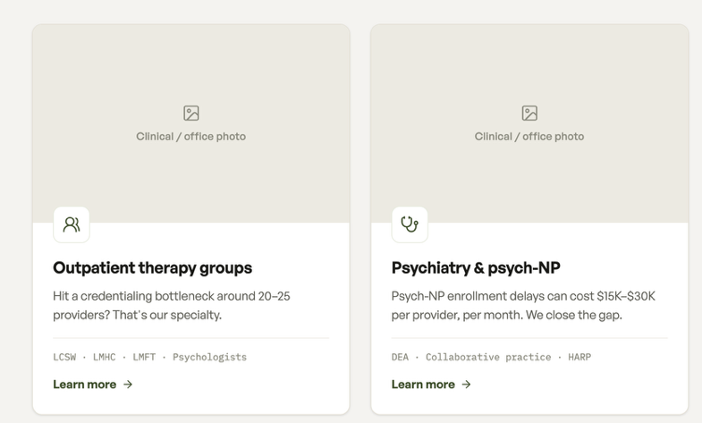 Add ABA as 3rd card

